Visiting Cape Cod > April 2022

As Patriots’ Week departed, it became time for our annual visit to Cape Cod, MA – the weather 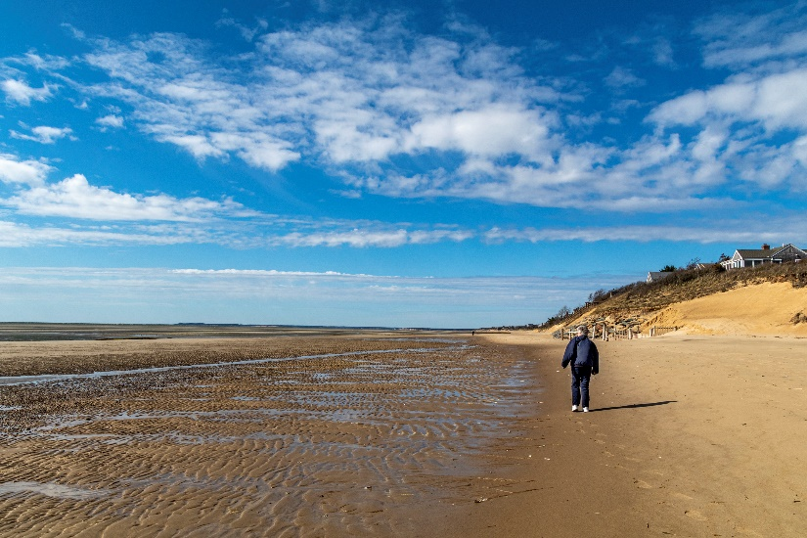regardless. Our favorite haunts were mostly open from Orleans to P–Town and we quite enjoyed the outdoors activities, occasional shopping, and the always different food choices. There is nothing like a 2+ - mile walk on the Bike Trail before breakfast followed by visits to familiar locations offering different enticements. Yes, the weather was very cold and the winds loved to streak past 30 mph – even grounding the whale watches for several days. Exploring low tide at First Encounter Beach in Eastham and roaming P-Townwith many spots in between provided a memorable trip. No whales, sharks, or live dolphins, but it was not for lack of looking.

As for the photos, click on the [Cape Cod – April -2022.](https://photos.app.goo.gl/ry3ZFELPXcJ7Thmh9)